**Casimir Pulaski School**

**\*School Choice Virtual Town Hall\***

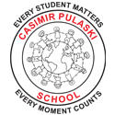

**WHO**: All prospective Yonkers Public Schools families

**WHAT**: Informational session about the school

**WHEN**: Wednesday, January 20, 2021

**TIME**: 9:30 am and 2:00 pm